Sadhana Pharmacy - Guide

Contents

Starting the application 2

Going to different pages 3

Viewing items 4

Adding items to Inventory 5

Deleting Items from Inventory 6

Editing items in Inventory 7

Searching Items by Name, Expiry Date, etc. 8

When items are Sold 10

Viewing Revenue 11

Total Revenue, and Searching Revenue by Date 12

Deleting Revenue 13

Closing the application 14

# Starting the application

Double click on the application’s icon, and the Home screen will start up.

From here, click on the Itemsbutton to add, remove, and sell items in the inventory. Or, click on the Sales button to save and view your revenues.

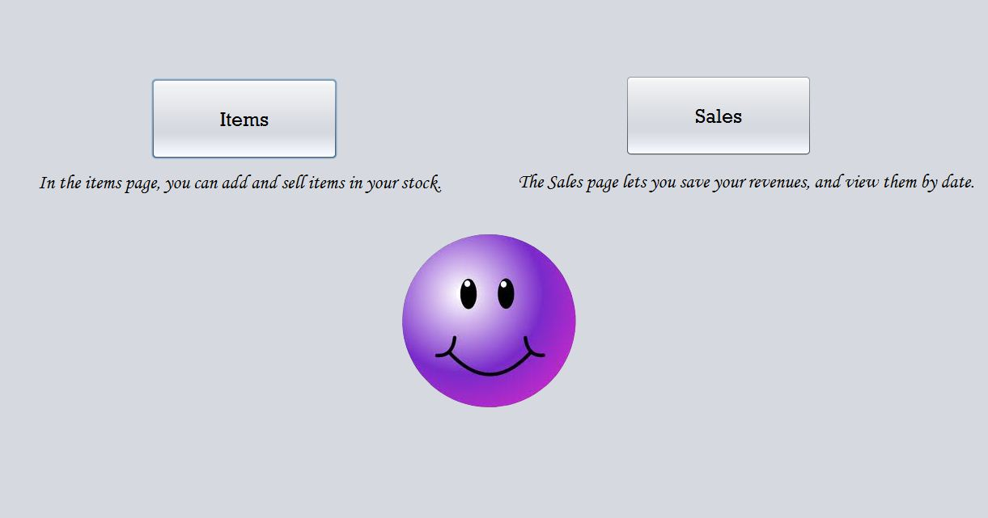

# Going to different pages

From the Items page, or the Sales page, you can see the navigation buttons. Click them to navigate to the page you wish.

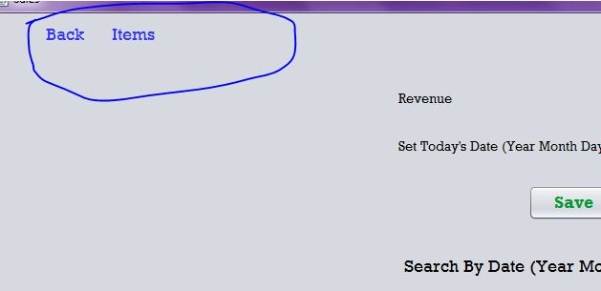

# Viewing items

Items may be viewed from the Items page. All items in the inventory are displayed in a table. All items are automatically arranged by their expiration year. Items expiring this year appear at the top of the table while items expiring on later years appear below.

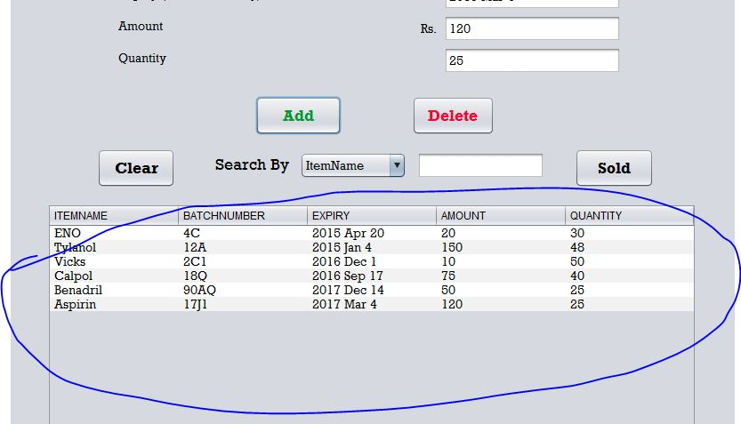

# Adding items to Inventory

From the Items page, fill in the item details - Name, Batch Number, Expiry date, Amount, and Quantity.

**Batch numbers MUST be unique.**

**Expiry Dates should be in the following format: Year, Month, Day. This will allow you to search for items first by Expiry Year, then by Expiry Month, then day.**

After all the details are filled out, click the Add button to save the item to inventory.

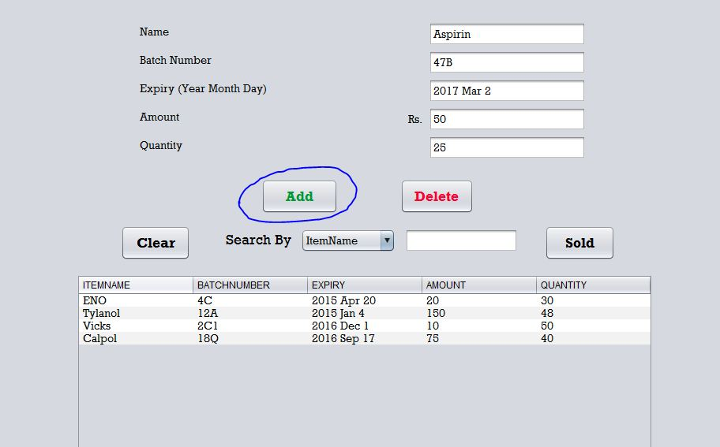

# Deleting Items from Inventory

Click on the item in the table, and click on the Delete button.

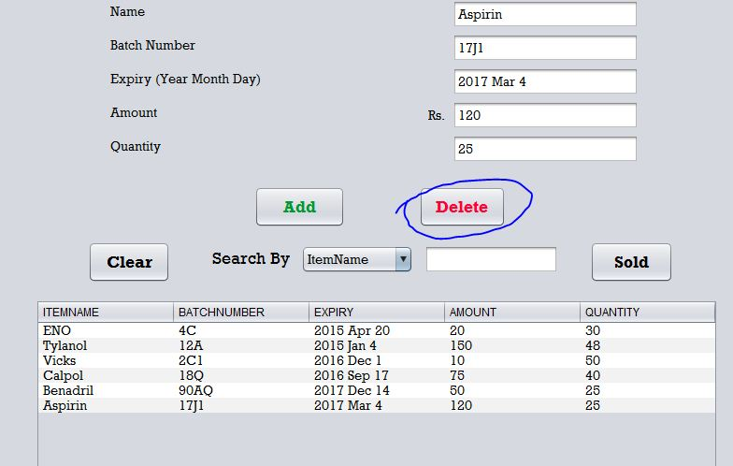

# Editing items in Inventory

Say you’ve entered the name of an item wrong, and you want to correct it. Just select the item from the table, and click on Delete. The item will be removed from inventory, but its details will be left in the text boxes above. Simply, make any changes you want, and click Add to add it back to Inventory.

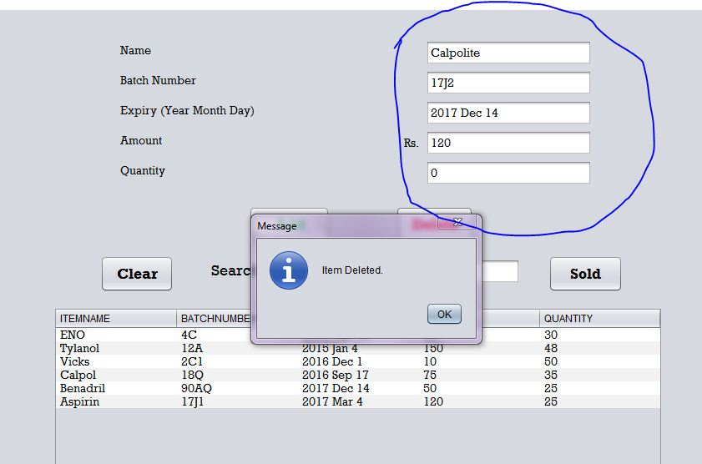

# Searching Items by Name, Expiry Date, etc.

Search by Name, by Expiry, and by Quantity are the most useful features.

Items may be viewed by their different attributes. Click on the Search By box, and choose an attribute – Item Name, Batch number, Expiry Date, Amount, and Quantity.

**By Item Name** - Type the name of an item in the Search By box, and press Enter. All items of that name will be displayed.

You may also type the 1st one or two letters of an item, and press Enter. Then, all the items starting with that letter will be displayed.

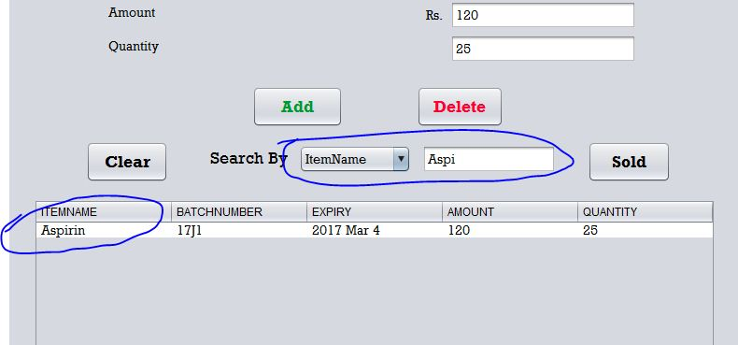

**By Batch Number –** Start typing the batch number of an item, and all items of that number will be displayed.

**By Expiry Date** – Type a year first, and press Enter. All items expiring in that year will be displayed. After the year, you may also type the month of expiry, and also the day. This feature is most useful when you want to know which items are expiring soon. Suppose, today is July 5th 2014. You may type 2014 June in the Search by Expiry box. This way, all the items that are expiring this month, will be displayed.

**Search expiry dates by typing the YEAR first, then the month, then the day, like 2016 Mar 4.**

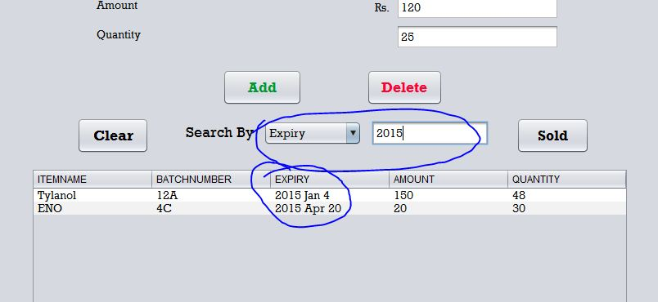

**By Amount** – Search items by their price.

**By Quantity** – Search items by how many you have in your inventory. This feature is most useful when you want to know which items are out of stock. Just type 0 in the box, and all items that are currently 0 in stock, will be displayed.

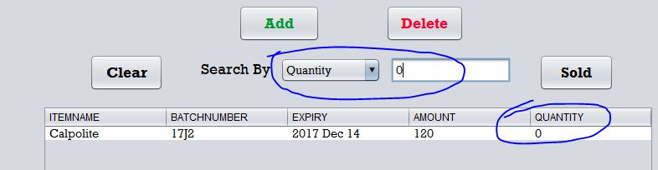

# When items are Sold

Click on an item in the table, and then click the Sold button. A message will appear asking how many quantities of that item were sold. Type a number, and click Ok. The quantity in stock will be updated.

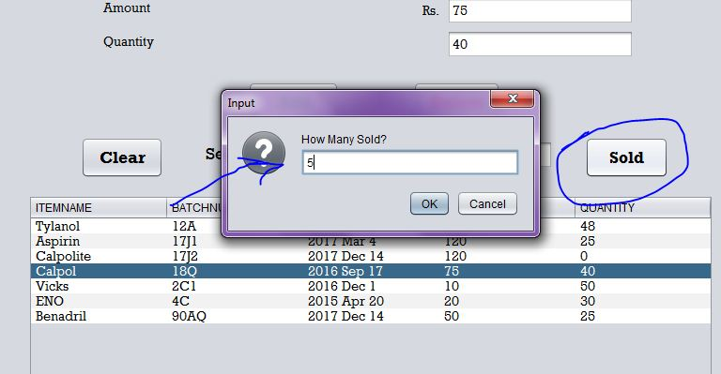

When you sell items, the prices of the items get added to your Revenue.

# Viewing Revenue

When items have been sold in Items page, the revenue box automatically displays how much money you earned that day.

To save the day’s revenue, type the current date in the Set Today’s Date box, and click Save.

**Please remember to type the date in this format: Year first, then Month, then Day.**

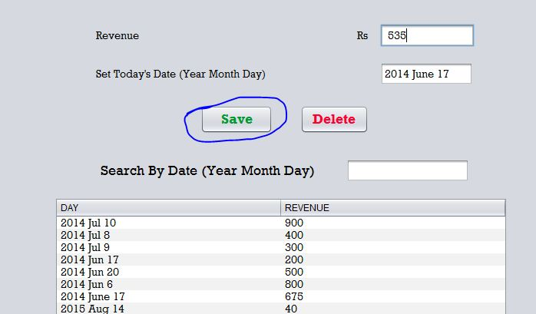

# Total Revenue, and Searching Revenue by Date

**Total Revenue** – When you enter the Sales page, the amount of money that you have earned till now is automatically displayed in the Total Revenue box. You can view your total earnings in a particular year, month, or day as well. Read below.

**Searching by Date** – This is another extremely useful feature. In the Search By Date box, type out a year first, say 2014. This shows you how much money you earned in that year. You may also type a month after the year, like 2014 Jul. This will show you the amount of money you earned in the month of July of 2014. You can also search by a specific date as well by typing a day, like 2014 Jul 24.

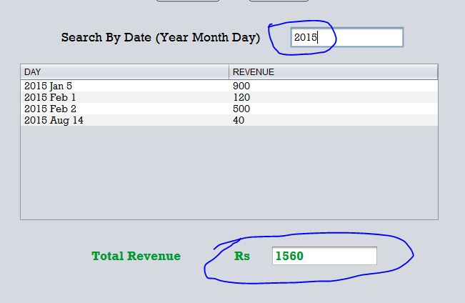

# Deleting Revenue

To delete entries from your Revenue, just click on the date you want to delete, and click the Delete button.

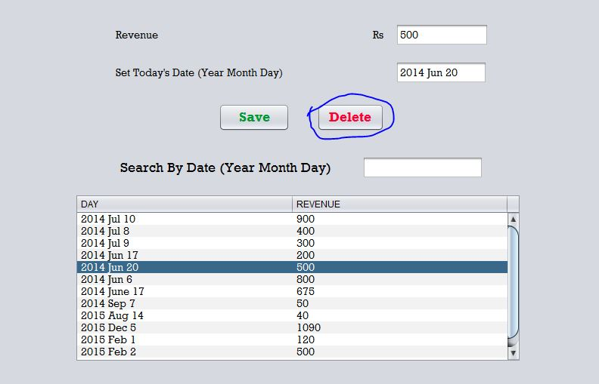

# Closing the application

Click on the red cross on the top right corner of the screen to close the application.